**STUDENT REGISTRATION SYSTEM**

**Course Name: Human-Computer Interaction**

**Semester: 2nd**

**Member #1: Amna Mubarak (20K-1695)**

**Member #2: Ehtesham Zafar (20K-1655)**

**Member #3: Hassan Ali (20K-1052)**

**DEDUCTIVE USER INTERFACE AND REASONING**

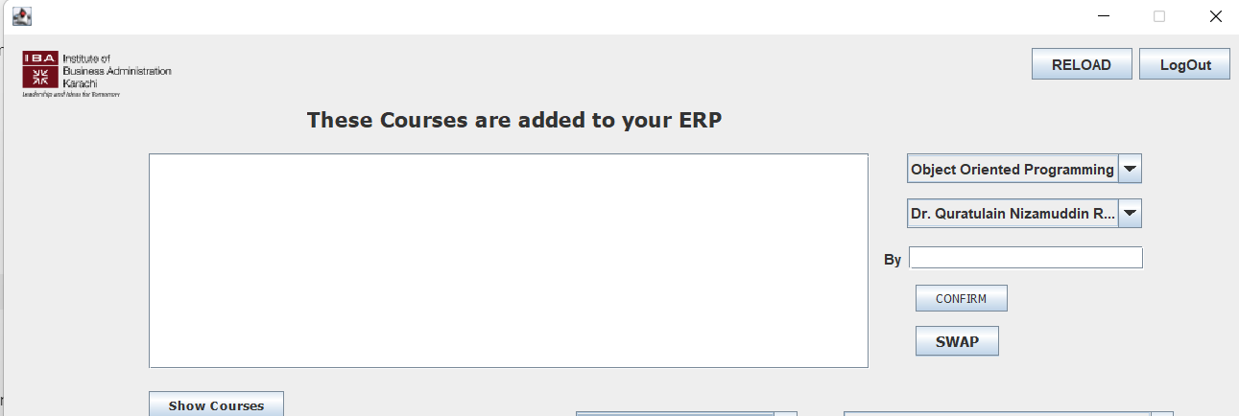

When a user will see this dialogue box, he will immediately think of operations related to it and will apply deductive reasoning. The user will figure out that information has to be either filled in the white rectangular box or to be displayed since it is empty. Some users will even attempt to type in this box. Afterwards, the user will inspect the buttons available and can see that the confirm button is initially disabled.

So he will explore other buttons like swap, show courses or maybe reload or log out. By closely looking at the drop-down menu of courses and instructors, questions will arise whether he has to choose an instructor for each course so that the confirm button will finally work. Here the swap button can also mislead the user in selecting courses or instructors since it does not mention what to swap explicitly.

The user has applied deductive reasoning in understanding the task and properly interacting with the system.

**INDUCTIVE USER INTERFACE AND REASONING**

An inductive user interface has especially been designed to avoid deductive reasoning. So whenever a user will explore any screen of that interface, he should know exactly what has to be done and how to do it.

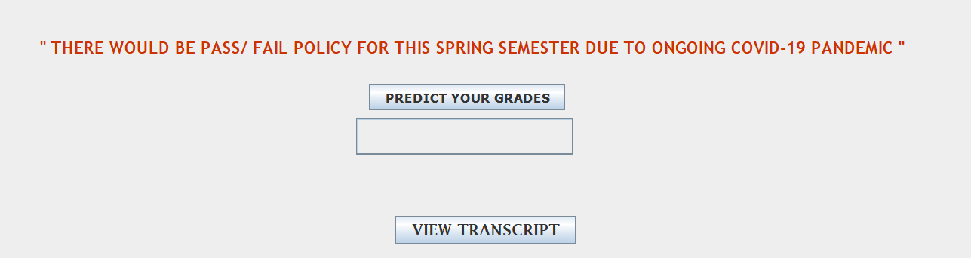

In this screen, we can see that software is deliberately focusing the attention of the user on a new screen with a single task and making it as the primary task. Although two operations are there and are interlinked in a way that makes it easier for a to deduct. The user can also sense the working since it is not an abstract method.



A link has been created for the secondary task (because it has diverted the user to a new screen) after the user presses the view transcript. So it will only display the relevant information to the user and cannot distract the user from the primary task even though the visual representation of the screen changes.

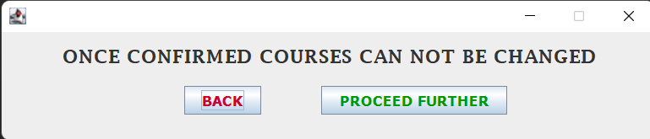

This is not just a dialogue box but the main screen of the software where the task is being so clearly stated that if the courses are confirmed the user must proceed further or go back. The screen title has been made so prominent so that the user does not misjudge. The screen content areas are equally distributed and two buttons have been placed.

**ABDUCTIVE USER INTERFACE AND REASONING**

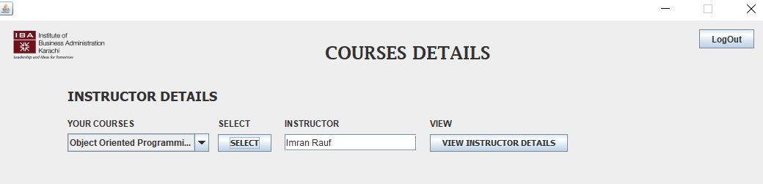

Abductive reasoning is inferring the cause of an event from the actual event.

This window displays the details of the course instructor but the users do not know which instructor’s details they can view. For example, by looking at this window the user may infer that this displays all the necessary information of each instructor. This inference of the users may or may not be true because they don’t actually know which instructor’s detail they can view. In reality, only those instructor’s details can be viewed which the user has chosen as their instructor.



So, here the inference of the users can also be true if they infer correctly but it can also be false if they infer incorrectly.